Roll No.:2503a52531
Name:B.Poojitha
Batch:18
Question 5. Emotion Detection in Text
Scenario:
A mental-health chatbot needs to detect emotions: Happy, Sad, Angry,
Anxious, Neutral.
Tasks:
1. Create labeled emotion samples.
2. Use Zero-shot prompting to identify emotions.
3. Use One-shot prompting with an example.
4. Use Few-shot prompting with multiple emotions.
5. Discuss ambiguity handling across techniques.

Prompt for ZERO-SHOT:
Identify the emotion in the following text.
Choose exactly one:
Happy, Sad, Angry, Anxious, Neutral.
Happy: The person expresses happiness or excitement.
Sad: The person expresses sadness or disappointment.
Angry: The person expresses anger or frustration.
Anxious: The person expresses worry or nervousness.
Neutral: The text does not clearly express an emotion.
Text:
{text}
Return only the emotion.

Code for ZERO-SHOT:
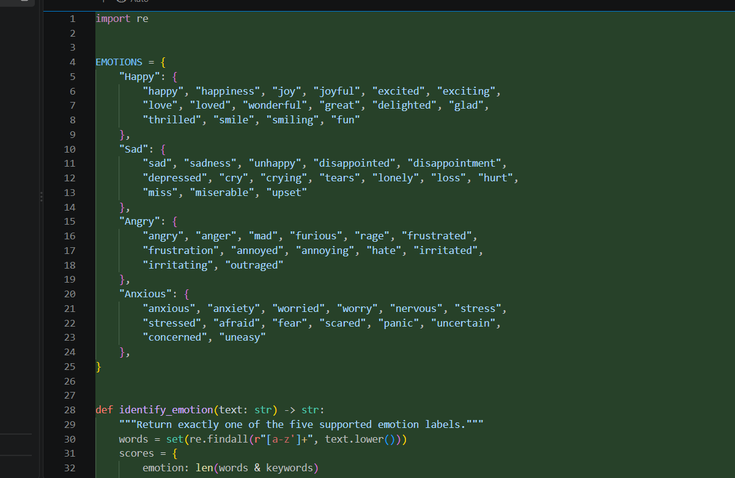
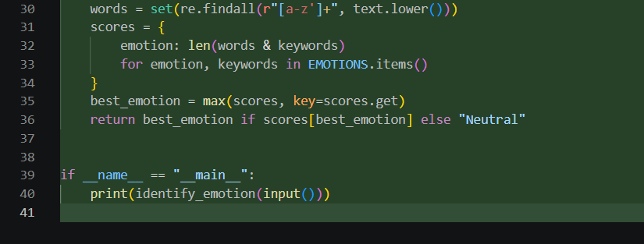

Output:
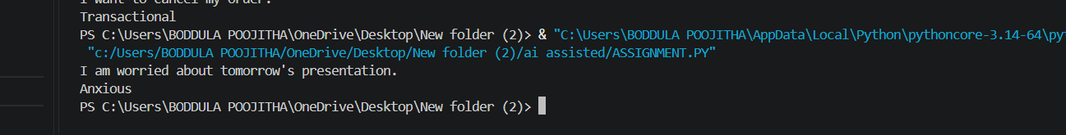

Prompt for ONE-SHOT;
Identify the emotion as Happy, Sad, Angry, Anxious, or Neutral.
Example:
Text: I am very happy with my results!
Emotion: Happy
Now identify the emotion:
Text:
{text}
Return only the emotion.

Code for ONE-SHOT:
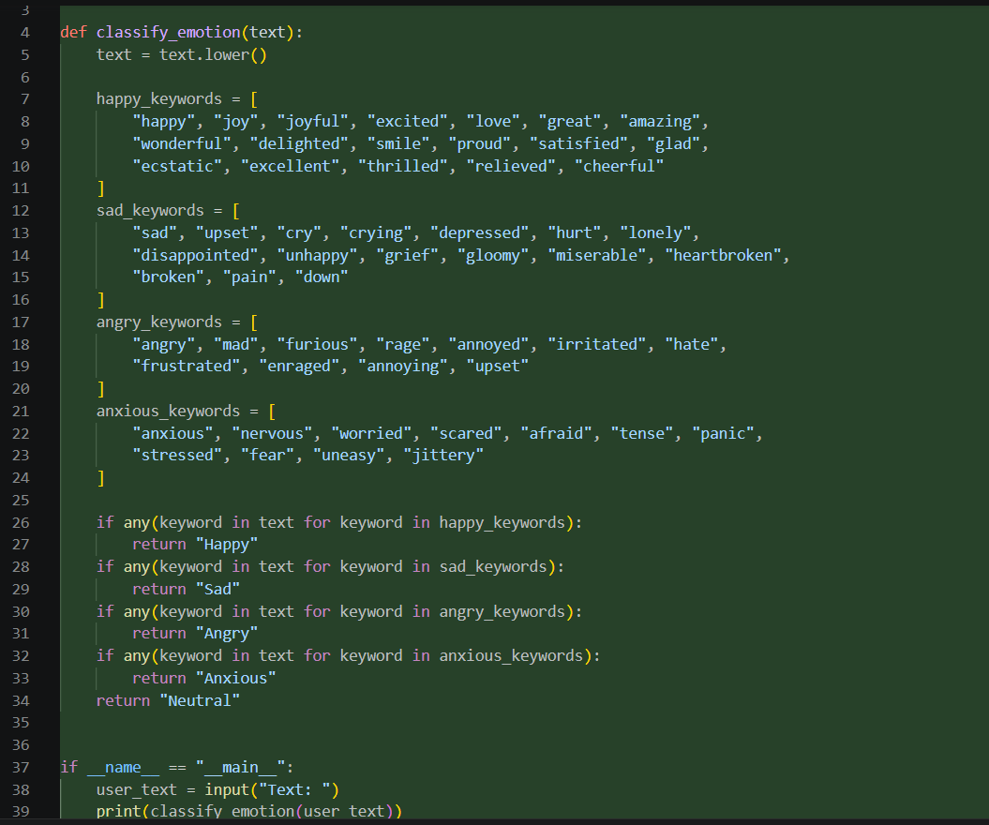

Output:
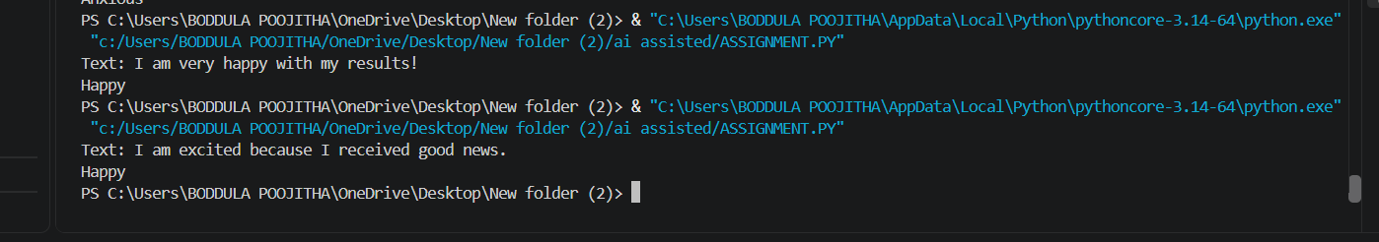

Prompt for FEW-SHOT:
Identify the emotion as Happy, Sad, Angry, Anxious, or Neutral.
Example 1:
Text: I am very happy with my results!
Emotion: Happy
Example 2:
Text: I feel disappointed about the result.
Emotion: Sad
Example 3:
Text: I am really angry about this problem.
Emotion: Angry
Example 4:
Text: I am worried about tomorrow's presentation.
Emotion: Anxious
Example 5:
Text: The meeting starts at 10 AM.
Emotion: Neutral
Now identify the emotion:
Text:
{text}
Return only the emotion.

Code for FEW-SHOT:
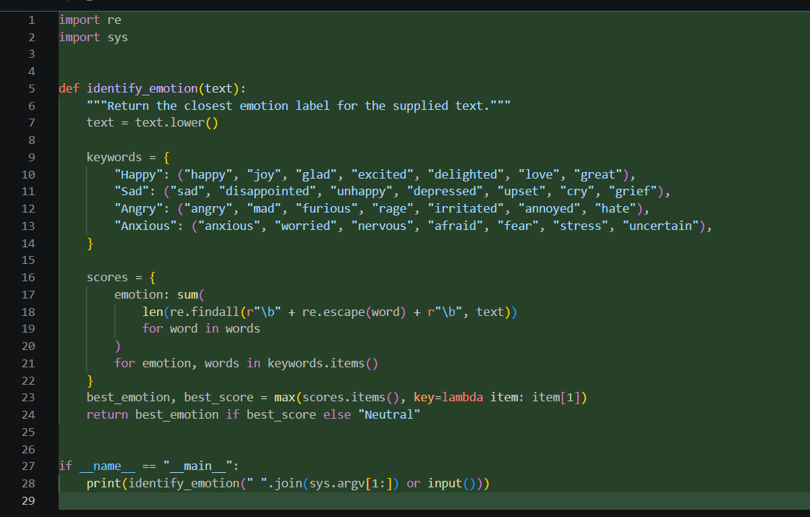

Output:
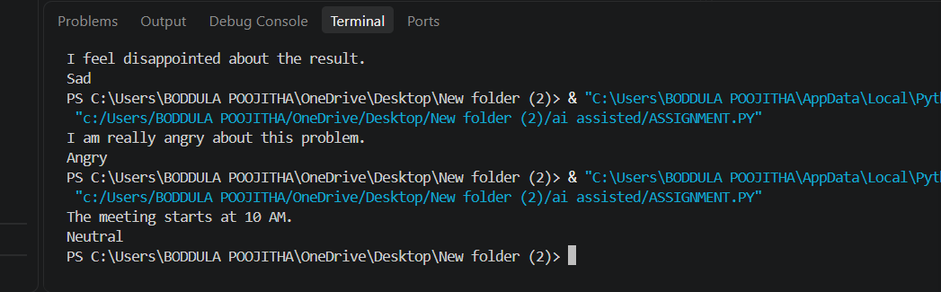

Observations:
1. Zero-shot prompting can identify clear emotions such as Happy, Sad, Angry, and Anxious without examples.
2. It may have difficulty when the text is ambiguous or expresses mixed emotions.
3. One-shot prompting provides one labeled example, which helps the model understand how the emotion should be classified.
4. Few-shot prompting provides examples of different emotions, making the classification more accurate and consistent.
5. Few-shot prompting helps distinguish between similar emotions, such as Sad and Anxious.
6. Neutral texts can be identified when there is no clear emotional expression.
7. Overall, few-shot prompting is expected to give the best results because multiple labeled examples guide the classification.

